# OOP LAB TASKS:04

Q1:

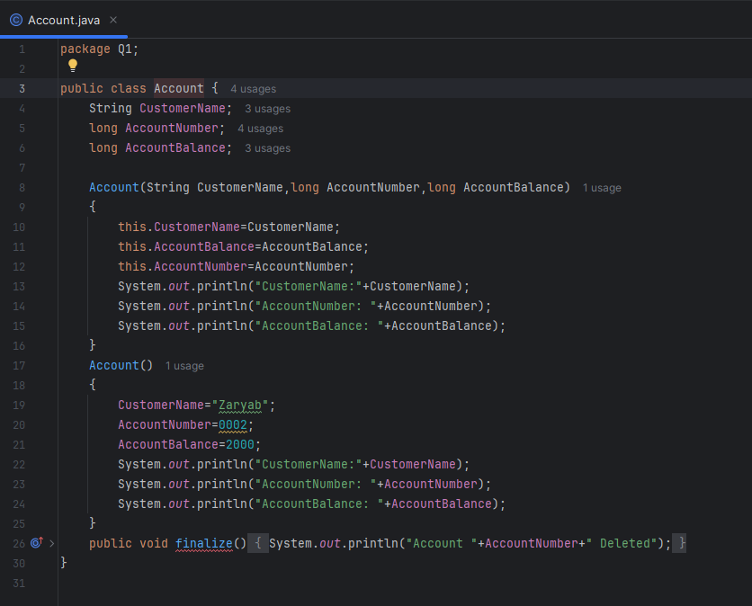

Output:

Q2:

Output:

Q3:

Output:

Q4:

Output:

Q5:

Output:

Q6:

Output:

Q7:

Output:

Q8:

Output:

Q9:

Output:

Q10:

1)Output:

Creating Laptop Object 1:

Appliance’s Default Constructor:

Appliance type: Electronics

Electronics Category: Laptop

Laptop Brand: No Brand

Laptop Ram: 8GB

Laptop’s Default Constructor

Creating Laptop Object 2:

Appliance's Default Constructor

Appliance Type: Electronic

Electronic Category: Laptop

Laptop Brand: Dell

Laptop RAM: 16GB

2)Constructor chaining:

First the user is calling any of the Laptop’s Constructor using different parameters. Then one of these Laptop constructor is calling either the constructor of the same class or the constructor of the its parent class (Electronic) using super() method. After calling the Electronic constructor, this electronic constructor then calls the constructor of its upper class (Appliance). And this how Constructor chaining is working in this code.

3)Constructor Chaining:

It is the process of one constructor calling another constructor of the same class or another class( Base Class ).

e.g:

class Electronic extends Appliance {

Electronic() {

this("General Electronic");

System.out.println("Electronic's Default Constructor");

}

Electronic(String category) {

super("Electronic");

System.out.println("Electronic Category: " + category);

}

}

Constructor overloading:

It is the process of creating more than 1 constructor of the same name using different parameters or different type of parameters.

e.g

Electronic() {

this("General Electronic");

System.out.println("Electronic's Default Constructor");

}

Electronic(String category) {

super("Electronic");

System.out.println("Electronic Category: " + category);

}

Q11:

1)Output:

Creating Player Object 1:

Champions Trophy 2025 Tournament Created

Host Country: Pakistan

Participating Team: Unknown Team

Player Name: Unknown Player

Player Role: All-Rounder

Player's Default Constructor

Creating Player Object 2: Champions Trophy 2025 Tournament Created

Host Country: Pakistan

Participating Team: Pakistan

Team Player Name: Babar Azam

Player Role: Captain

2) First the user is calling any of the Player’s Constructor using different parameters. Then one of these Player constructor is calling either the constructor of the same class or the constructor of the its parent class (Team) using super() method. After calling the Team constructor, this electronic constructor then calls the constructor of its upper class (Tournament). And this how Constructor chaining is working in this code.

3) Constructor Chaining:

It is the process of one constructor calling another constructor of the same class or another class( Base Class ).

e.g:

Tournament() {

System.out.println("Champions Trophy 2025 Tournament Created");

}

Tournament(String hostCountry) {

this();

System.out.println("Host Country: " + hostCountry);

}

Constructor overloading:

It is the process of creating more than 1 constructor of the same name using different parameters or different type of parameters.

e.g

Team()

{

\\ lines of code

}

Team(String teamName){

\\ lines of code

}

4)Modified Code:

Output:

Q12:

Output;

